

**Arpita Sahu**

**Data Analytics and Visualization Job Simulation**

# Certificate of Completion

August 22nd, 2024



Inspiring and empowering

future professionals

Over the period of August 2024, Arpita Sahu has completed practical tasks in:

Project Understanding

Data Cleaning & Modeling

Data Visualization & Storytelling

Present to the Client

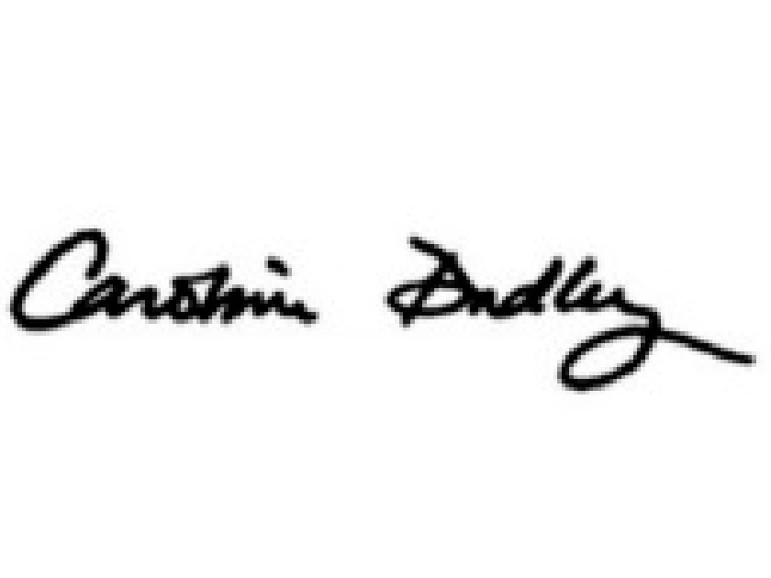

**Caroline Dudley** **Tom Brunskill**

Managing Director CEO, Co-Founder of

North America Forage

Recruiting

Enrolment Verification Code bY3vLTRYzhEJuR5XZ | User Verification Code DE5ZmnwuT8sHKB7gq | Issued by [Forage](http://theforage.com/)